# Pivoting on One Variable - Corrected Instruction 1

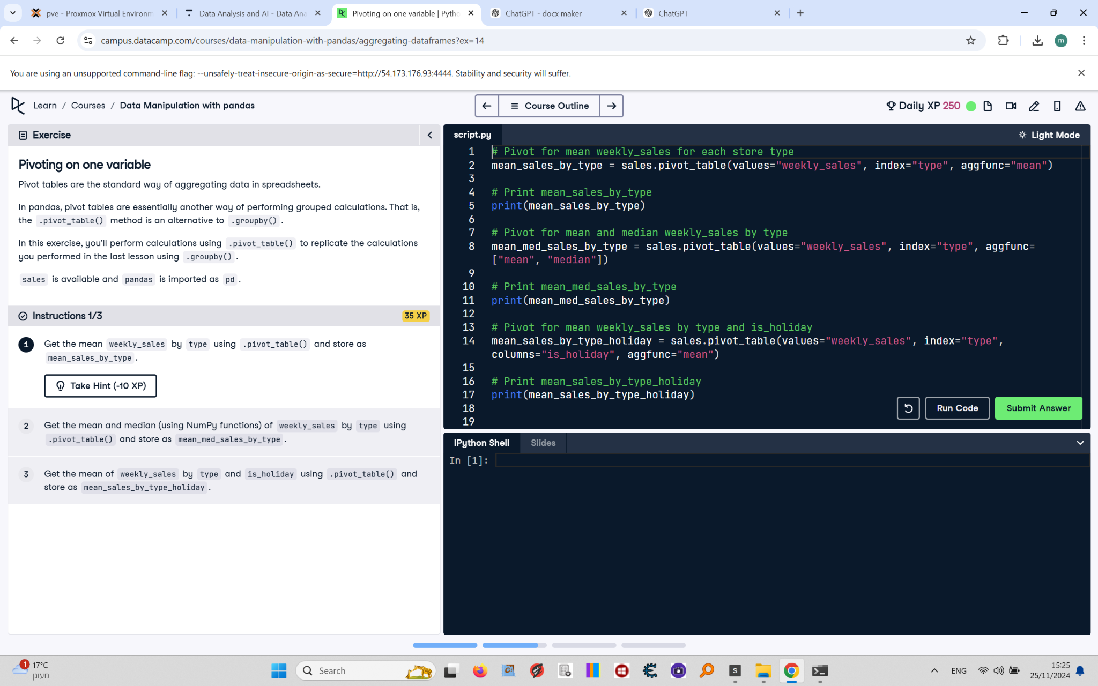

Pivot tables are the standard way of aggregating data in spreadsheets.  
  
In pandas, pivot tables are essentially another way of performing grouped calculations. That is, the pivot_table() method is an alternative to .groupby().  
  
In this exercise, you'll perform calculations using .pivot_table() to replicate the calculations you performed in the last lesson using .groupby().  
  
sales is available and pandas is imported as pd.

## Corrected Final Answer - Instruction 1

# Pivot for mean weekly_sales for each store type  
mean_sales_by_type = sales.pivot_table(values="weekly_sales", index="type")  
  
# Print mean_sales_by_type  
print(mean_sales_by_type)